**Hotel Booking Analysis**

**Nitesh Bhowmick**

**Ayush Goyal, Sameer Ahmed,**

**Data science trainees,**

**Alma Better, Bangalore**

**Abstract:**

The study conducted was on the proposed “Hotel Booking Analysis”. The main purpose of this study was to create a program that will automate the current system used by the hotel. The researchers used the descriptive type of survey methods where they distributed questionnaires to the respondent of the study as a research instrument for data gathering.

Our experiment can help understand what could be the reason for the classification of such labels by feature selection, data analysis and prediction with Python Programming taking into account previous trends to determine the correct classification.

**1. Problem Statement**

This data set contains booking information for a city hotel and a resort hotel and includes information such as assigned room type, lead time, the number of adults, children and/or babies, arrival date, stays in weekend nights, stays in week nights, reservation status and the number of available parking spaces, among other things. All personally identifying information has from the data. We will perform exploratorydata analysis with python to get insight from the data.

**2. Introduction**

Hotel Booking System is complete hotel management system that manages all operations in the hotel industry business. It works by processing online reservation securely through hotel’s website. This hotel data can be accessed by hotels to manage bookings and provides instant confirmation for hotel reservations.

Hotel management Software is complete hotel quotation management system which automates hotel operations, manage real-time hotel room availability, rates, and other hotel data to increase online bookings, improve guest booking experience and maximize hotel revenues.

Hotel Booking Software is complete hotel reservation system which is easily integrated in hotel website allowing guests to make online reservations through hotel website and provide hoteliers with hotel channel management and other resources to improve customer experience and increase online bookings.

Hotel Booking System is complete hotel quotation booking system that comes with the key role of Hotel XML IN, Hotel XML Out, Hotel Channel Manager, Hotel Extranet and Own Contracting to help hotels to automate day-to-day hotel operations and increase bookings

It allows hoteliers to provide their customers with best options for hotel rooms, amenities coupled with online booking and payment option to improve guest experience from booking to post-stay.

Before selecting Hotel Booking System, you must see that hotel booking system features are exact match for your business.

### .**3. Key features of Hotel Booking System:-**

* Hotel Search and Book Functionality
* Reservation Management
* Channel Management
* Hotel API Integration
* Back-office management
* Multiple-currency feature
* Multilanguage feature
* Payment Gateway Integration
* Mobile-responsive design
* Detailed Reports

### **4. Benefits of Hotel Booking System:-**

* Easily integrate in Hotel Website
* Simplify Hotel Booking Process
* Instant Booking Confirmation
* Reduces operational costs
* Saves Time
* Online Hotel Inventory Distribution
* Hotel management.
* Improve Customer booking

experience

* Increase booking and revenue

### **5.** **Key Role of Hotel Booking System:**

**Hotel Extranet:**

It allows travel agents and hoteliers to upload their partner or supplier hotels and gives access to online system to update hotel inventory online.

#### **OTH (Own Contracting):**

It allows hoteliers to upload your own contracted hotels i.e., all hotel info such as room allocation, room types, occupancy, meals, room rates, etc. and sell directly contracted hotels.

#### **Hotel XML IN:**

The hotel inventory is dynamically integrated into online travel portal of travel agents and hoteliers enabling to provide their customers with high-quality accommodations at competitive prices from global suppliers.

#### **Hotel XML OUT:**

Allow to distribute your own hotel inventory to travel partners and sub agents through XML Out of your system via XML/API.

#### **Hotel Channel Manager:**

Allows hotels to distribute their inventory across various online channels and maximize their selling capacity and increase bookings.

**6. Steps involved:**

* **Exploratory Data Analysis**

 Booking across years is higher for city hotel compared to resort hotel and increases from year 2015 to 2016 and again decreases in 2017 compared to year 2016. Booking across months is higher for city hotels compared to resort hotel, booking increases in monsoon and summer seasons and decreases in winter season. Repeated guest is slightly correlated with Previous bookings not cancelled; this means Repeated guests generally don’t cancel their previous bookings. Total guests are slightly correlated with adr which means more number of guests means more revenue hence more adr. Most Guests from Portugal and European countries compared to other countries in the world. Online TA is mostly preferred for hotel booking than offline TA/TO, But other mediums are rarely used. that prices in the resort are much higher during the summer and prices of city hotel varies less and is most expensive during spring and autumn.

* **Null values Treatment**

Our dataset contains a large number of null values which might tend to disturb our accuracy hence we dropped them at the beginning of our project in order to get a better result.

* **Missing values Treatment**

We see that some columns have missing data but few of those columns have the more missing data. As these columns are not relevant for our analysis so, we can delete them & few columns have low missing data, we will remove the full row of missing data

* **Standardization of features**

In these steps we used adding & Rename the column in data frame for analyzing data conveniently

Our main motive through this step was to scale our data into a uniform format that would allow us to utilize the data in a better way while performing fitting and applying different type of Analysis to it.

The basic goal was to enforce a level of consistency or uniformity to certain practices or operations within the selected environment.

* **Fitting different models**

For Analysis we tried various types of plot & charts like:

1. **Count Plot & Sub Plot with Heat Map**
2. **Bar Chart.**
3. **Pie Chart & Choropleth Map.**
4. **Line Chart in Matplotlib**
5. **Scatter Plot.**

**7. Algorithms:**

1. **Count Plot & Sub Plot with Heat Map:**

A count plot is kind of like a histogram or a bar graph for some categorical area. It simply shows the number of occurrences of an item. Create a data frame with keys, col1 and col2, using Pandas. Use countplot() to show the counts of observations in each categorical bin using bars. Adjust the padding between and around the subplots.

 A heatmap contains values representing various shades of the same color for each value to be plotted. Usually the darker shades of the chart represent higher values than the lighter shade. For a very different value a completely different color can also be used. based on a certain type of catalog.

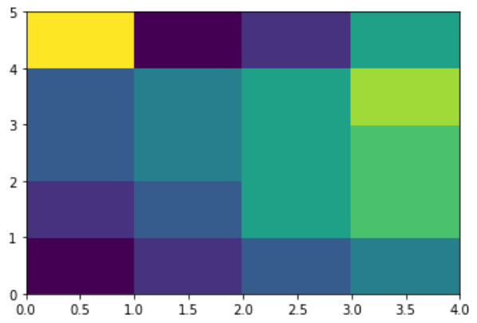

In Bar chart we use the optimization as:

*seaborn.heatmap(data, *, vmin=None, vmax=None, cmap=None, center=None, annot_kws=None, linewidths=0, linecolor=’white’, cbar=True, **kwargs)*

.

1. **Bar Chart :**

A bar chart or bar graph is a chart or graph that presents categorical data with rectangular bars with heights or lengths proportional to the values that they represent. The bars can be plotted vertically or horizontally. A vertical bar chart is sometimes called a column chart. Bar charts show the frequency counts of values for the different levels of a categorical or nominal variable

In Bar chart we use the optimization as:

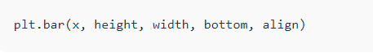

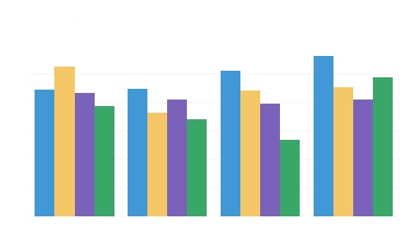

1. **Pie Chart & Choropleth Map. :**

A pie chart is a circle that is divided into areas, or slices. Each slice represents the count or percentage of the observations of a level for the variable. Pie charts are often used in business.

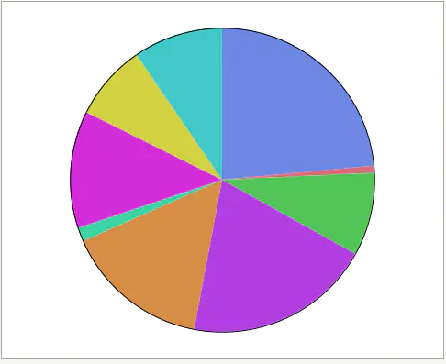

In Pie chart we use the optimization as:



A choropleth map can be used to visualize the unemployment rates in police districts across the city and compare them to crime rates. Darker areas in the above map indicate high levels of unemployment, while lighter areas indicate low levels of unemployment.

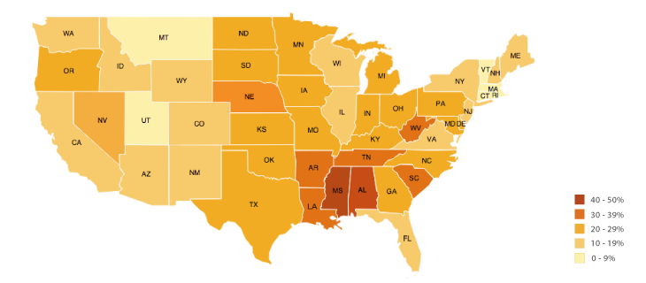

In choropleth map we use the optimization as:

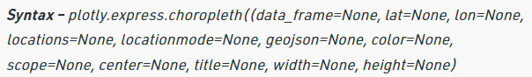

1. **Line Chart in Matplotlib:-**

**Matplotlib** is a data visualization library in Python. The[**pyplot**](https://www.geeksforgeeks.org/pyplot-in-matplotlib/), a sub library of Matplotlib, is a collection of functions that helps in creating a variety of charts.  **Line charts**are used to represent the relation between two data X and Y on a different axis**.** We can display more than one chart in the same container by using [pyplot.figure ()](https://www.geeksforgeeks.org/matplotlib-pyplot-figure-in-python/) function. This will help us in comparing the different charts and also control the look and feel of charts.

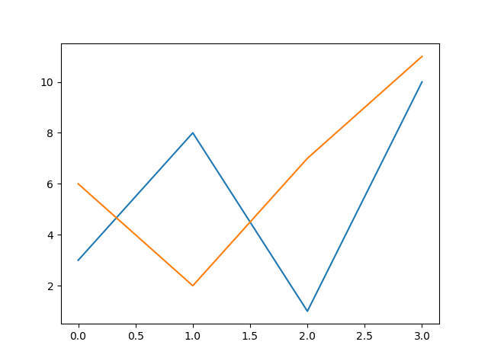

In Line Chart in Matplotlib we use the optimization as:



1. **Scatter Plot:**

A scatter plot is a diagram where each value in the data set is represented by a dot. The Matplotlib module has a method for drawing scatter plots; it needs two arrays of the same length, one for the values of the x-axis, and one for the values of the y-axis.

Scatter plots are used to plot data points on horizontal and vertical axis in the attempt to show how much one variable is affected by another. Each row in the data table is represented by a marker the position depends on its values in the columns set on the X and Y axis

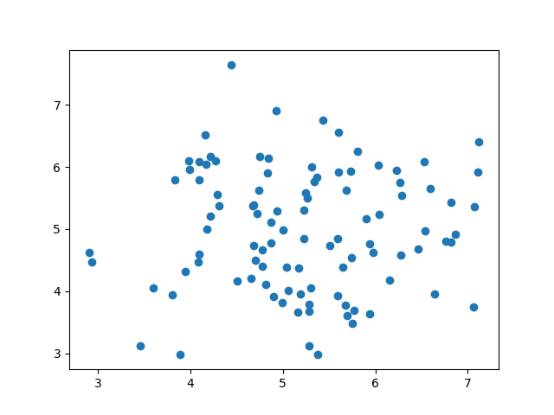

In Line Chart in Matplotlib we use the optimization as:

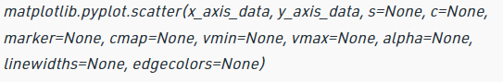

.

**8. Conclusion:**

* The majority of the reservations are for city hotel than resort hotel and most in the year 2016.
* The majority of the reservations are in the mason and summer seasons
* The guests are correlated with the adr which increases the revenue of the hotel
* Most of the guests come from Portugal and other European countries.
* Most of the Hotel Booking is done by online TA market segment and offline TA/TO market segment.
* Resort hotel prices are higher than the city hotel and most expensive in August and July.
* Possibility of cancellation of booking increases with increase in lead time.
* Most of guests prefer to stay in the hotel less than 5 nights.

**References-**

1. Geeks for Geeks
2. Analytics Vidhya